HOSPITAL MANAGEMNET SYSTEM

**BACHELOR OF TECHNOLOGY**

(**Computer Engineering)**



**MARCH,2022**

**SUBMITTED BY: -**

GROUP NAME: **B1 Group (Akshat Amla, Jeevanjot Singh, Arjun Kapoor, Amisha Gurndwal)**

BRANCH: **CSE**

SEMESTER: 1

**ACKNOWLEDGEMENT**

Through this section of my report, I want to present my gratitude towards my institute MIET, being able to work on projects, that require you to analyse and solve a problem that exists in real world, is an experience that one can achieve rarely, and I am happy and thankful to get that chance here.

I would also like to thank HOD sir and teachers who gave us such an opportunity to develop or skills.

Lastly, I want to thank my parents and colleagues who have been a support system throughout my life and help me lessen my burden and stress of work

**TABLE OF CONTENTS**

1. INTRODUCTION
2. FLOWCHART
3. TECHNICAL SKILLS(Coding)
4. OUTPUTS
5. REFERENCE

**INTRODUCTION**

Health of citizen is the wealth of Nation. India has contributes to the most ancient Medical science "AYURVEDA” the world besides other medical sciences. This field had witnessed a rapid metamorphosis in all of its sections. Hospital Management System is designed to improve the quality and management of hospital in the areas of clinical process analysis and activity-based costing. Hospital Management System enables you to develop your organization and improve its effectiveness and quality of work. Managing the key processes efficiently is critical to the success of the hospital helps you manage your processes. The data can be retrieved easily. The data are well protected for personal use and makes the data processing very fast. Hospital Management System is powerful, flexible, and easy to use and is designed and developed to deliver real conceivable benefits to hospitals.

So, the embedded management system which is created by my team in c language with the help of structures and file handling includes the features of adding, viewing, editing, searching and deleting a patient’s details

**FLOWCHART**

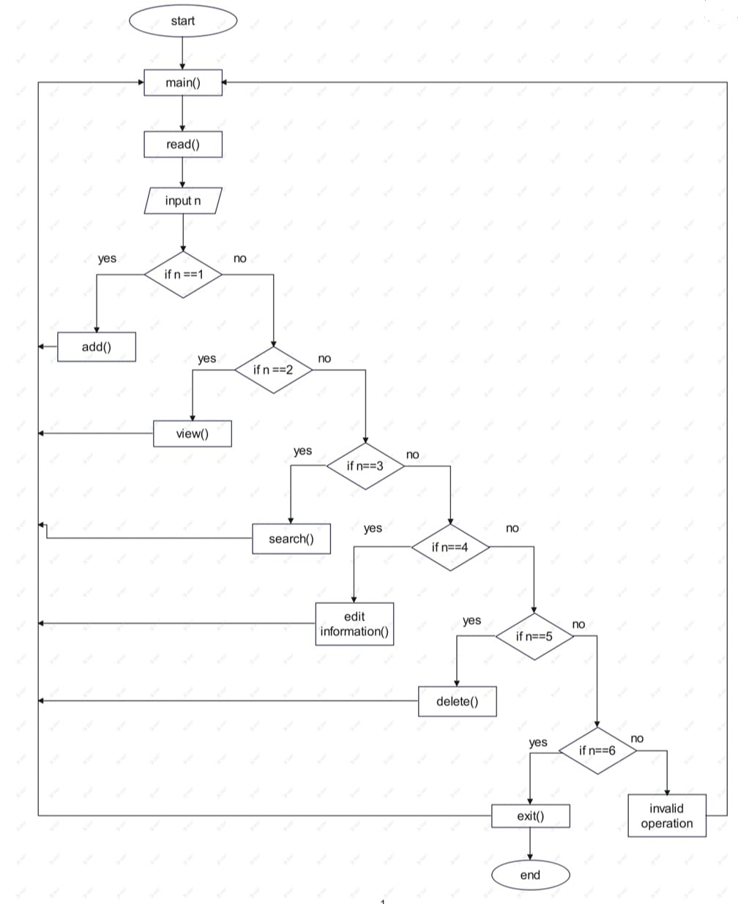

**TECHNICAL DETAILS(Coding)**

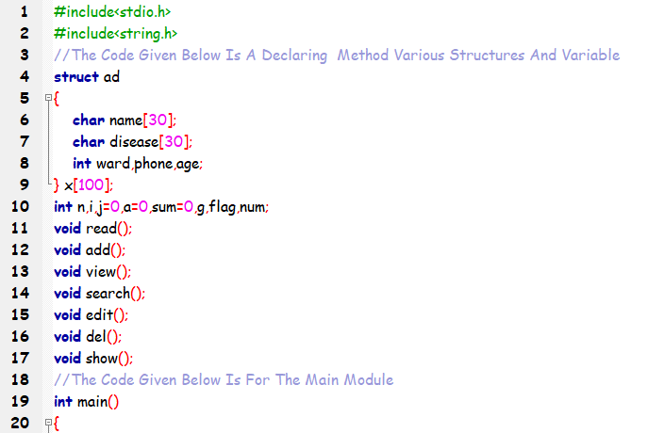

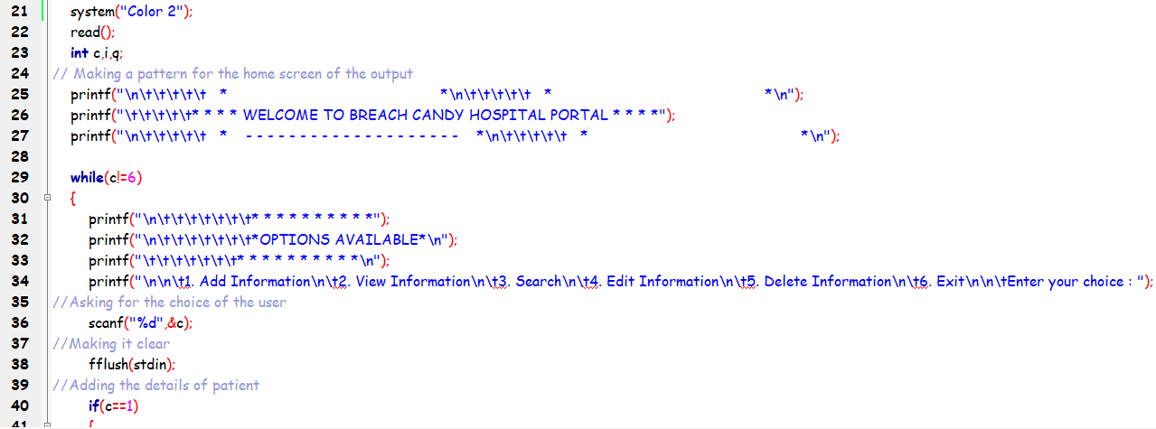

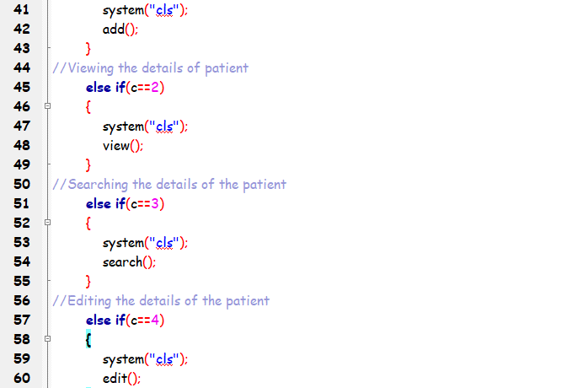

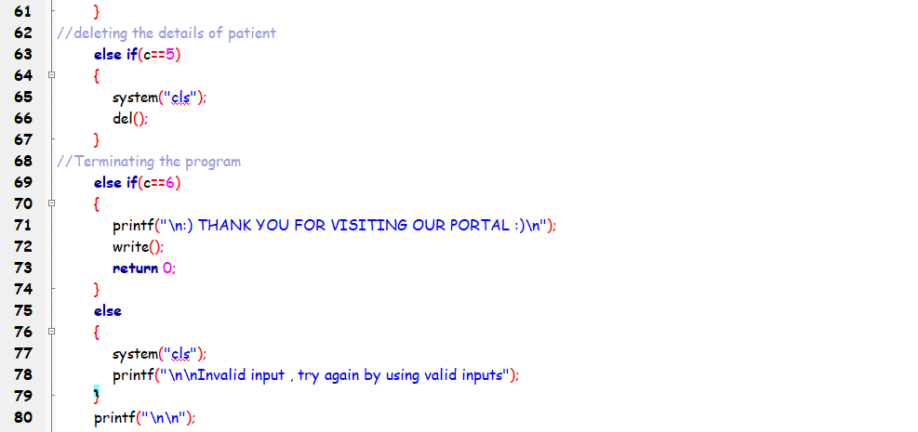

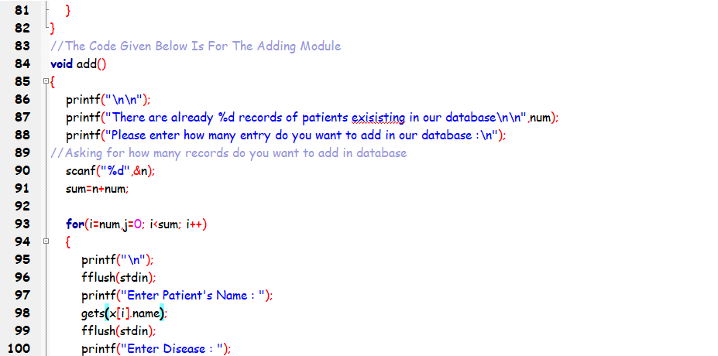

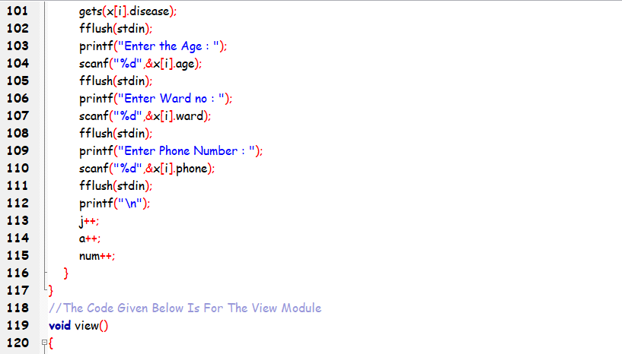

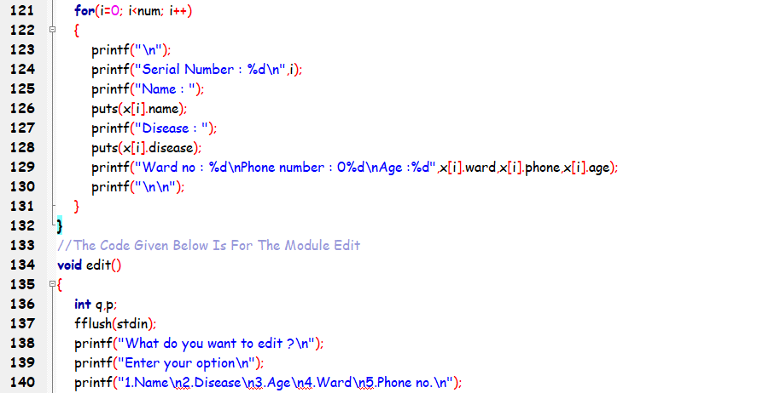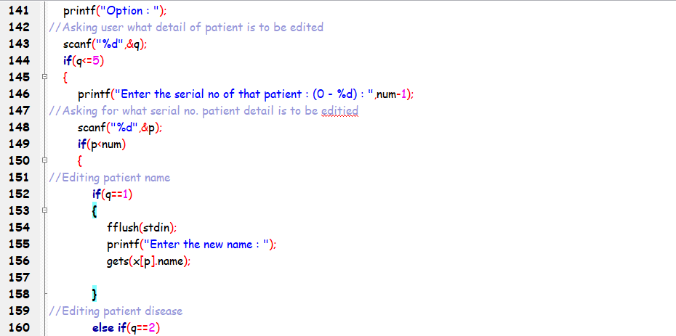

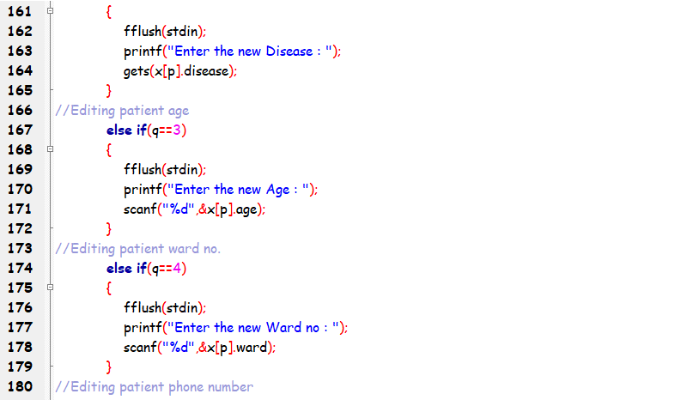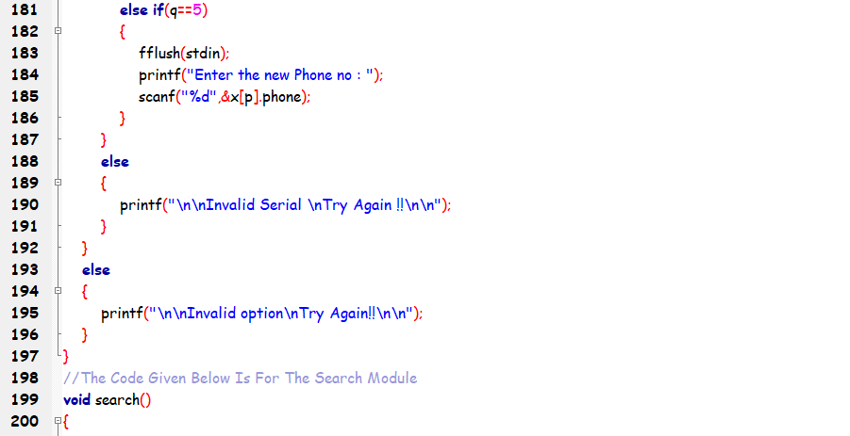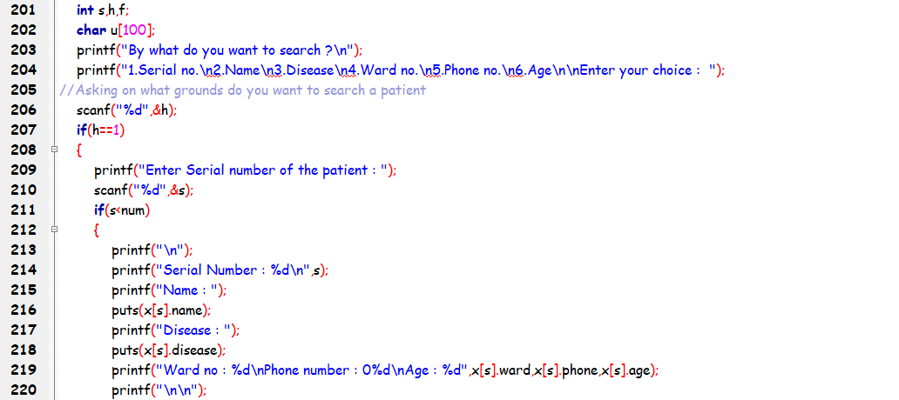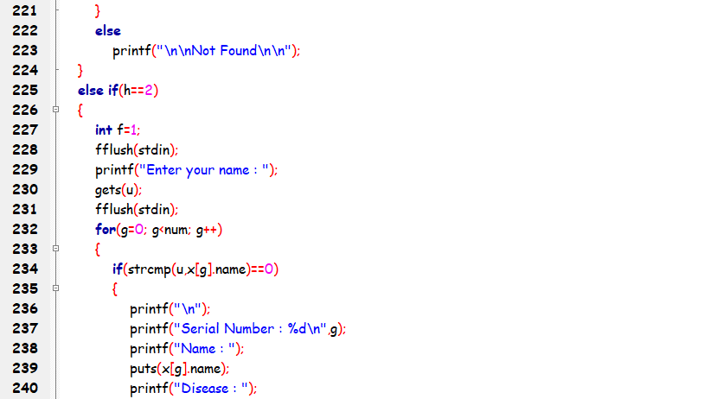

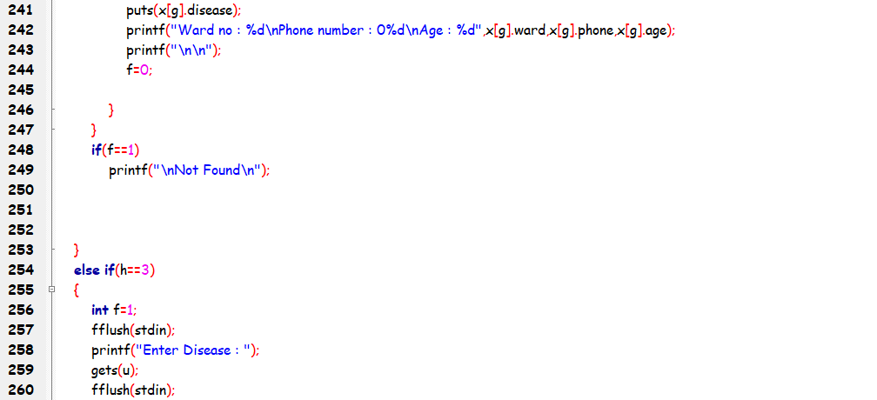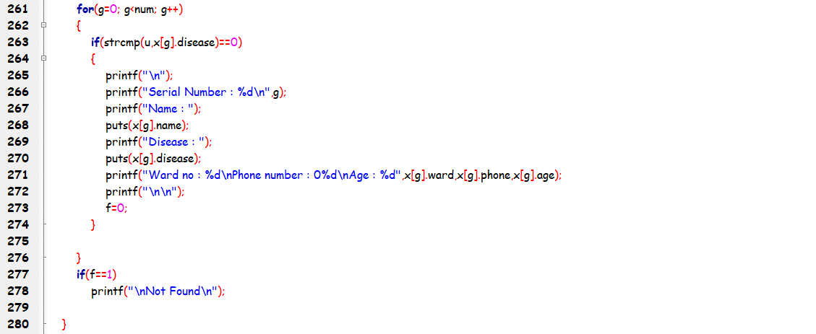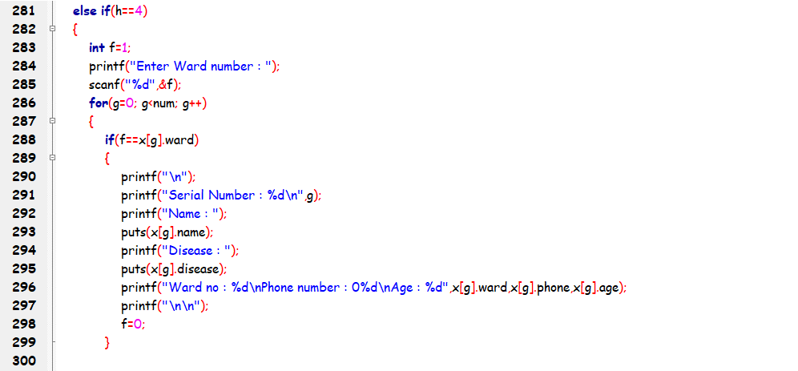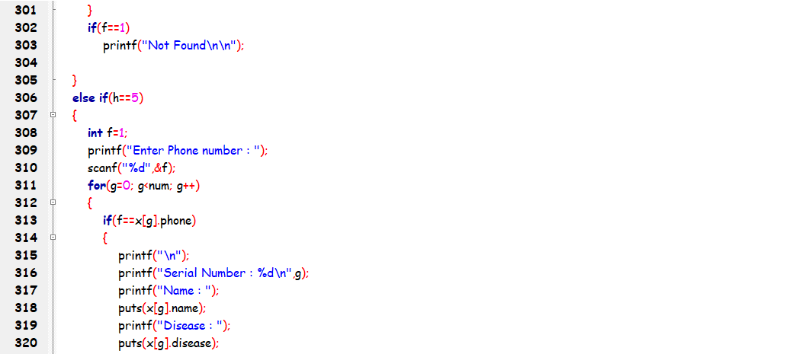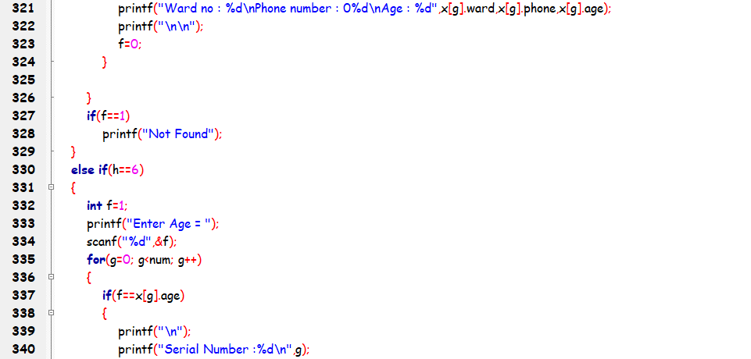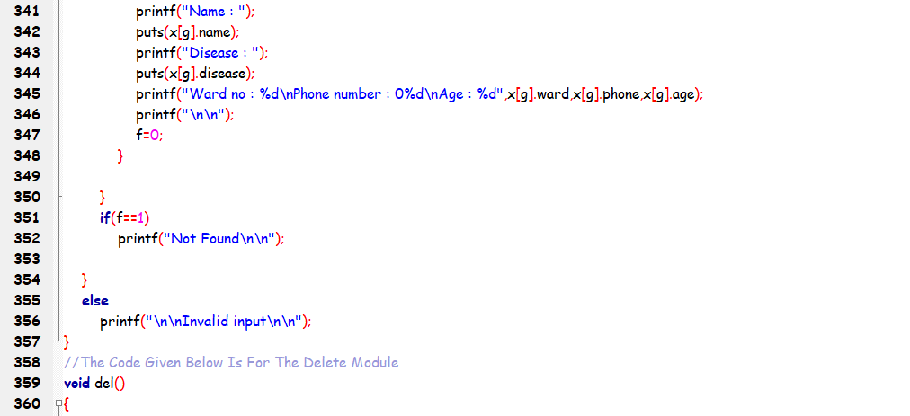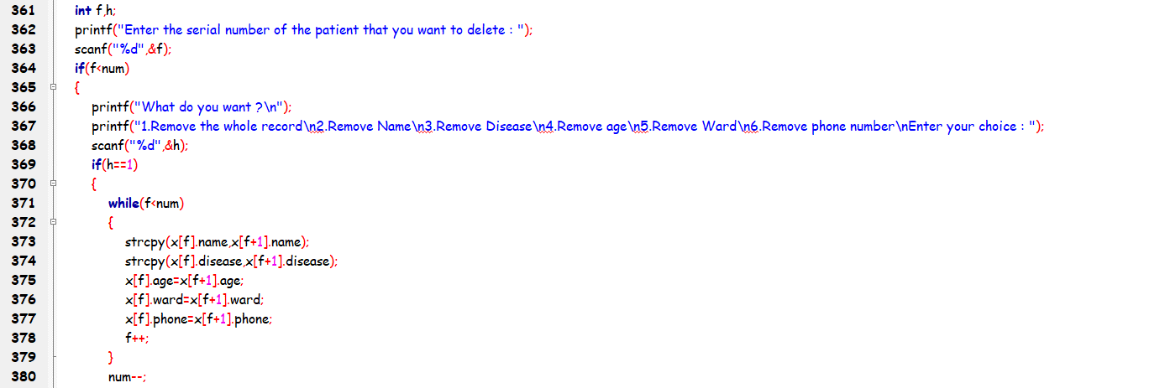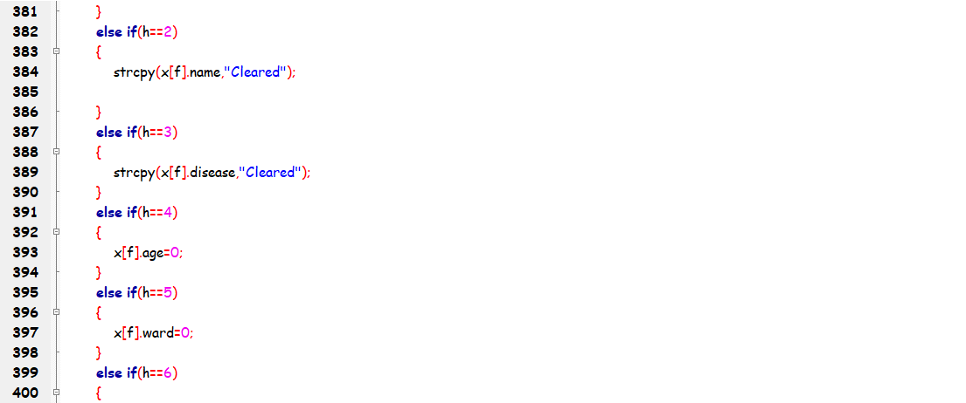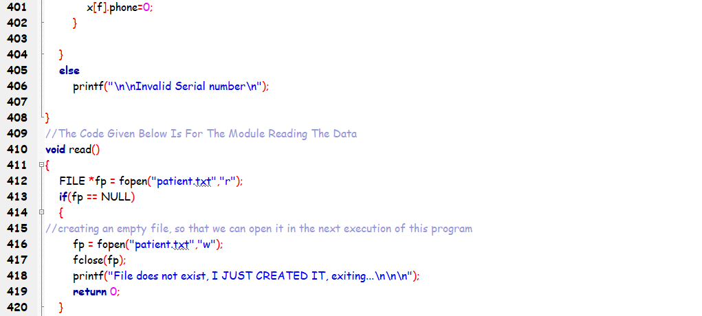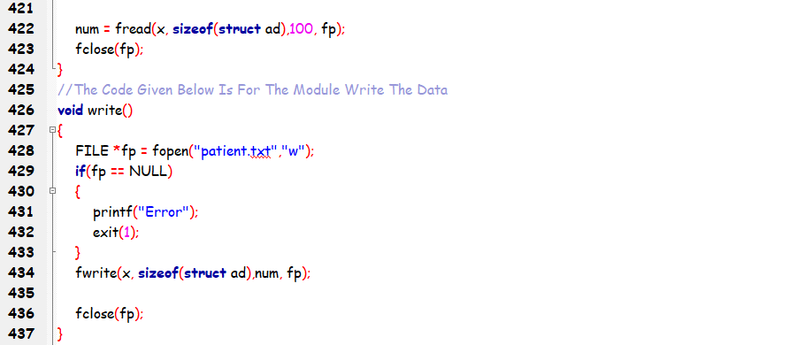

**OUTPUTS**

Main screen: -

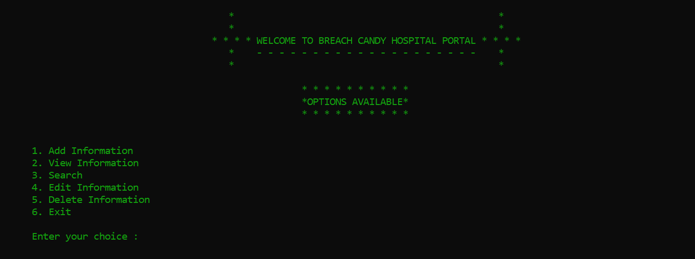

Adding patient details: -

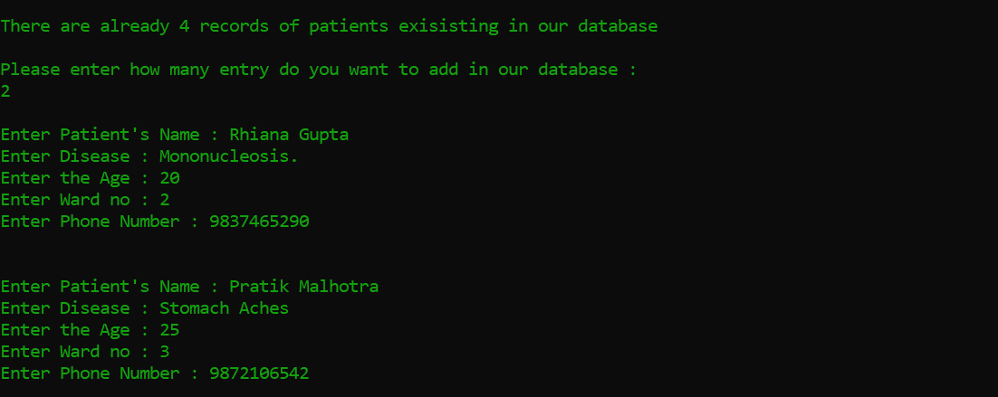

Viewing patient details: -

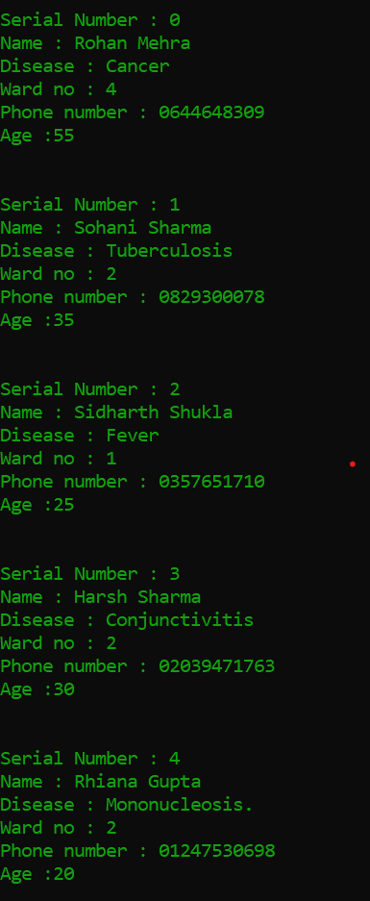

Searching patient details: -

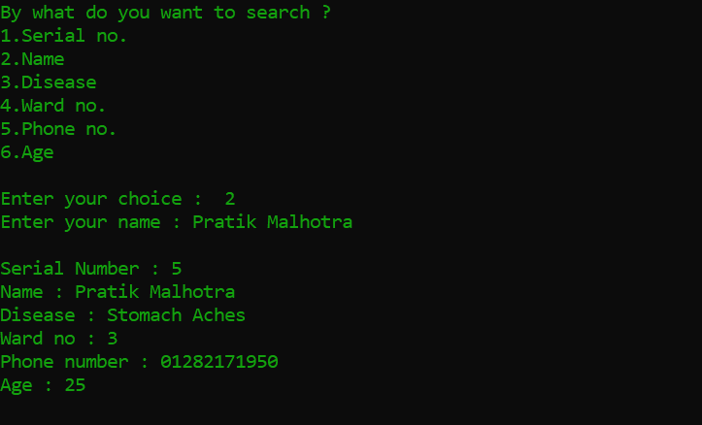

Editing patient details: -

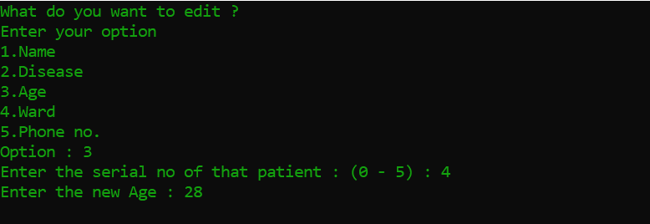

Deleting patient details: -

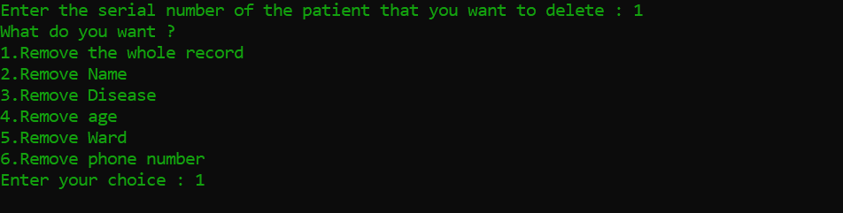

**REFERENCES**

Referred Links for completion of the project

* <https://www.geeksforgeeks.org/>
* <https://www.tutorialspoint.com/index.htm>
* <https://www.codingninjas.com/>

Books referred for completion of the project

* Programming with C | 4th Edition (Schaum's Outlines) By Byron S Gotftfried
* The C Programming Language | 2nd Edition By Brian Kernighan and Dennis Ritchie